**VISVESVARAYA INSTITUTE OF TECHNOLOGY**

**Jnana Sangama, Belagavi-590010**



MINI PROJECT REPORT

ON

“**IMPLEMENTATION OF ONLINE VOTING SYSTEM**”

Submitted in partial fulfillment for the requirements for the fifth semester curriculum

**BACHELOR OF ENGINEERING**

**IN**

**COMPUTER SCIENCE AND ENGINEERING**

For the Academic year 2018-2019

Submitted by:

**ASHISH KUMAR DUBEY 1MV16CS021**

**ARUN SINGH 1MV16CS020**

Project carried out at:

**Sir M. Visvesvaraya Institute of Technology**

Bengaluru-562157

Under the guidance of:

**Mrs. SAPNA R**

Asst. Professor, Department of CSE

Sir M. Visvesvaraya Institute of Technology, Bengaluru



**DEPARTMENT OF COMPUTER SCIENCE AND ENGINEERING**

**SIR. M VISVESVARAYA INSTITUTE OF TECHNOLOGY**

HUNASAMARANAHALLI, BENGALURU-562157

SIR M. VISVESVARAYA INSTITUTE OF TECHNOLOGY

BENGALURU -562157

DEPARTMENT OF COMPUTER SCIENCE AND ENGINEERING



CERTIFICATE

It is certified that the project work entitled “**IMPLEMENTATION OF ONLINE VOTING SYSTEM**” is a bonafide work carried out **by ASHISH KUMAR DUBEY(1MV16CS021) , ARUN SINGH(1MV16CS020)** in partial fulfilment for the requirements of mini project for the V semester curriculum  Bachelor of Engineering in Computer Science and Engineering of the Visvesvaraya Technological University, Belagavi during the year 2018-2019 . It is certified that all corrections and suggestions indicated for Internal Assessment have been incorporated in the report. The project report has been approved as it satisfies the academic requirements in respect of Project work prescribed for the course of Bachelor of Engineering.

Name & Signature of Guide       Name & Signature of HOD

**Mrs. SAPNA R Dr. G.C. BHANUPRAKASH**

Asst. Prof & Internal Guide Prof & HOD, Dept of CSE

Dept. Of CSE, Sir MVIT Sir MVIT Bengaluru - 562157 Bengaluru -562157

External Examination:

Name of the Examiners                                                        Signature with date

1)

2)

**ACKNOWLEDGMENT**

It gives us immense pleasure to express our sincere gratitude to the management of **Sir M. Visvesvaraya Institute of Technology,** Bangalore for providing the opportunity and the resources to accomplish our project work in their premises.

On the path of learning, the presence of an experienced guide is indispensable and we would like to thank our guide **Mrs. SAPNA R,** Assistant Professor, Dept. of CSE, for her invaluable help and guidance.

We would also like to convey our regards and sincere thanks to **Prof. G.C. Bhanuprakash** HOD, Dept. of CSE for his suggestions, constant support and encouragement, Heartfelt and sincere thanks to **Prof. V.R. MANJUNATH,** Principal, Sir. MVIT for providing us with the infrastructure and facilities needed to develop our project.

We would also like to thank the staff of Department of Computer Science and Engineering and lab-in-charges for their co-operation and suggestions. Finally, we would like to thank all our friends for their help and suggestions without which completing this project would not have been possible.

* ASHISH KUMAR DUBEY (1MV16CS021)
* ARUN SINGH (1MV16CS020)

DECLARATION

We hereby declare that the entire mini project work embodied in this dissertation has been carried out by us and no part has been submitted for any degree or diploma of any institution previously.

Place: Bengaluru

Date:

Signature of Students:

ASHISH KUMAR DUBEY (1MV16CS021)

ARUN SINGH(1MV16CS020)

ABSTRACT

The word “vote” means to choose from a list, to elect or to determine. The main goal of voting (in a scenario involving the citizens of a given country) is to come up with leaders of the people’s choice. Most countries, Kenya not an exception have problems when it comes to voting. Some of the problems involved include ridging votes during election, insecure or inaccessible polling stations, inadequate polling materials and also inexperienced personnel.This online voting/polling system seeks to address the above issues. It should be noted that with this system in place, the users, citizens in this case shall be given ample time during the voting period. They shall also be trained on how to vote online before the election time.

TABLE OF CONTENTS

**CERTIFICATE 2**

**ACKNOWLEDGEMENT 3**

**DECLARATION 4**

**ABSTRACT 5**

**TABLE OF CONTENTS 6**

**LIST OF FIGURES 8**

**CHAPTER 1 INTRODUCTION 9**

* 1. Introduction To OVS 9
  2. Background Of Study 10
  3. Significance Of Study 11
  4. Objective Of Project 11
  5. Project Justification 11
  6. Scope Of Study 11
  7. Old Method Of Voting 12
  8. Security Issues In OVS 12
  9. Requirements 12
  10. Problems With The Existing Voter Registration System 13

**CHAPTER 2 SPECIFICATIONS 9**

2.1 Hardware Requirements 14

2.2 Software Requirements 14

2.3 Functional Requirements 14

2.4 Non-Functional Requirements 15

**CHAPTER 3 SYSTEM DESIGN 16**

3.1 Introduction 16

3.2 Dataflow Diagram 16

3.3 Use Case Diagram 18

3.4 E R Diagram 18

**CHAPTER** **4** **FRONT-END BACK-END 21**

**CHAPTER 5 IMPLEMENTATION** 23

5.1 Downloading The Required Software 22

5.2 Running Mysql And Creating Database On Mysql 22

5.3 Create Table And Insert Values 23

5.4 Frontend Code In Java And Connection To Database 24

5.5 How The Functions Are Working 26

**CHAPTER 6 RESULTS AND SNAPSHOTS 28**

**CONCLUSION** 34

**REFERENCES**

LIST OF FIGURES

Sl. No. Title of the figure Page No.

Fig 3.1 Data Flow Diagram 17

Fig 3.3 Use Case Diagram 19

Fig 3.4 Project Work Flow Diagram 20

Fig 5.1 Mysql Database Creation 22

Fig 5.2 Creating Tables And Inserting Values 23

Fig 5.3 Tables List 23

Fig 5.4 Netbeans IDE Project Creation 24

Fig 5.5 Java Files And Supporting Images And Forms 25

Fig 5.6 Login User Interface 26

Fig 5.7 Admin Login 27

Fig 5.8 Voter Login 28

Fig 6.1 Adding Voter 29

Fig 6.2 Adding Candidate 30

Fig 6.3 Candidate List And Voter List 31

Fig 6.4 Update Voter 32

Fig 6.5 Counting 33

Fig 6.6 Result 33

**CHAPTER 1: INTRODUCTION**

**1.1 INTRODUCTION TO ONLINE VOTING SYSTEM**

“ONLINE VOTING SYSTEM” is an online voting technique. In this system people who have citizenship of Kenya and whose age is above 18 years of age and any sex can give his\her vote online without going to any physical polling station. There is a database which is maintained in which all the names of voters with complete information is stored.

In “ONLINE VOTING SYSTEM” a voter can use his\her voting right online without any difficulty. He\She has to be registered first for him/her to vote. Registration is mainly done by the system administrator for security reasons. The system Administrator registers the voters on a special site of the system visited by him only by simply filling a registration form to register voter. Citizens seeking registration are expected to contact the system administrator to submit their details. After the validity of them being citizens of India has been confirmed by the system administrator by comparing their details submitted with those in existing databases such as those as the Registrar of Persons, the citizen is then registered as a voter.

After registration, the voter is assigned a secret Voter ID with which he/she can use to log into the system and enjoy services provided by the system such as voting. If invalid/wrong details are submitted, then the citizen is not registered to vote.

**1.2 BACKGROUND OF STUDY**

The ONLINE VOTING SYSTEM (OVS) also known as e-voting is a term encompassing several different types of voting embracing both electronic means of counting votes. Electronic voting technology can include punched cards, optical scan voting systems and specialized voting kiosks (including self contained direct recording electronic voting systems or DRE). It can also involve transmission of ballots and votes via telephones, private computer networks, or the internet.

Online voting is an electronic way of choosing leaders via a web driven application. The advantage of online voting over the common “queue method” is that the voters have the choice of voting at their own free time and there is reduced congestion. It also minimizes on errors of vote counting. The individual votes are submitted in a database which can be queried to find out who of the aspirants for a given post has the highest number of votes.

This system is geared towards increasing the voting percentage in Kenya since it has been noted that with the old voting method {the Queue System}, the voter turnout has been a wanting case. With system in place also, if high security is applied, cases of false votes shall be reduced.

With the “ONLINE VOTING SYSTEM”, a voter can use his\her voting right online without any difficulty. He\She has to register as a voter first before being authorized to vote. The registration should be done prior to the voting date to enable data update in the database.

However, not just anybody can vote. For one to participate in the elections, he/she must have the requirements. For instance, he/she must be a registered citizen i.e. must be 18 and above years old. As already stated, the project ‘Online Voting' provides means for fast and convenient voting and access to this system is limited only to registered voters.

Internet voting systems are appealing for several reasons which include; People are getting more used to work with computers to do all sorts of things, namely sensitive operations such as shopping and home banking and they allow people to vote far from where they usually live, helping to reduce absenteeism rate.

**1.3 SIGNIFICANCE OF STUDY**

The main purposes of OVS include:

* Provision of improved voting services to the voters through fast, timely and convenient voting.
* Reduction of the costs incurred by the Kenyan Electoral Commission during voting time in paying the very many clerks employed for the sake of the success of the manual system.
* Check to ensure that the members who are registered are the only ones to vote. Cases of “Dead People” voting are also minimized.
* ONLINE VOTING SYSTEM (OVS) will require being very precise or cost cutting to produce an effective ONLINE VOTING SYSTEM.
* Therefore crucial points that this (OVS) emphasizes on are listed below.

1. Require less number of staff during the election.
2. This system is a lot easier to independently moderate the elections and subsequently reinforce its transparency and fairness.
3. Less capital, less effort, and less labor intensive, as the primary cost and effort will focus primarily on creating, managing, and running a secure online portal.
4. Increased number of voters as individual will find it easier and more convenient to vote, especially those abroad.

**1.4 Objectives Of The PROJECT**

The specific objectives of the project include:

* Reviewing the existing/current voting process or approach in Kenya;
* Coming up with an automated voting system in Kenya;
* Implementing a an automated/online voting system;
* Validating the system to ensure that only legible voters are allowed to vote.

**1.5 Project Justification**

The ONLINE VOTING SYSTEM-INDIA shall reduce the time spend making long queues at the polling stations during voting. It shall also enable the voters to vote from any part of the globe as explained since this is an online application available on the internet. Cases of vote miscounts shall also be solved since at the backend of this system resides a well developed database using MYSQL that can provide the correct data once it’s correctly queried. Since the voting process shall be open as early as possible, the voters shall have ample time to decide when and whom to vote for.

**1.6 SCOPE OF STUDY**

It is focused on studying the existing system of voting in Kenya and to make sure that the peoples vote is counts, for fairness in the elective positions. This is also will produce:

* Less effort and less labor intensive, as the primary cost and focus primary on creating, managing, and running a secure web voting portal.
* Increasing number of voters as individuals will find it easier and more convenient to vote, especially those abroad.

**1.7 Old Methods Of Voting**

1. **Paper-based voting**: The voter gets a blank ballot and use a pen or a marker to indicate he want to vote for which candidate. Hand-counted allots is a time and labour consuming process, but it is easy to manufacture paper ballots and the ballots can be retained for verifying, this type is still the most common way to vote.

2. **Lever voting machine**: Lever machine is peculiar equipment, and each lever is assigned for a corresponding candidate. The voter pulls the lever to poll for his favourite candidate. This kind of voting machine can count up the ballots automatically. Because its interface is not user friendly enough, giving some training to voters is necessary.

3. **Direct recording electronic voting machine**: This type, which is abbreviated to DRE, integrates with keyboard; touch screen, or buttons for the voter press to poll. Some of them lay in voting records and counting the votes is very quickly. But the other DRE without keep voting records are doubted about its accuracy.

4. **Punch card**: The voter uses metallic hole-punch to punch a hole on the blank ballot. It can count votes automatically, but if the voter’s perforation is incomplete, the result is probably determined wrongfully.

5. **Optical voting machine**: After each voter fills a circle correspond to their favourite candidate on the blank ballot, this machine selects the darkest mark on each ballot for the vote then computes the total result. This kind of machine counts up ballots rapidly. However, if the voter fills over the circle, it will lead to the error result of optical-scan. Recent years, a considerable number of countries has adopted E-voting for their official elections. These countries include; America, Belgium, Japan and Brazil.

**1.8 SECURITY ISSUES OF ONLINE VOTING**

Foreign experience revealed that they are often confronted by security issues while the online voting system is running. The origin of the security issues was due to not only outsider (such as voters and attackers) but also insider (such as system developers and administrators), even just because the inheritance of some objects in the source code are unsuitable. These errors caused the voting system to crash.

The proposed solutions were correspondingly outlined to hold back these attacks. For example, to avoid hacker making incursion into the voting system via network, we can design our system to transmit data without network. Another example is to limit voter to input particular data, so that we can prevent the command injection from running

**1.9 Requirements:**

1) Registration of the voter is done by ELECTION COMMISION OF INDIA.

2) ELECTION COMMISION OF INDIA can change the information any time if required.

3) Registration of the Voter depends upon the information filled by the user.

4) Voter is given a unique ID and PASSWORD.

5) In the DATABASE information of every voter is stored.

6) Database shows the information of every user.

**1.10 Problems with the Existing Voter Registration System**

The problems of the existing manual system of voting include among others the following:

1. **Expensive and Time consuming**: The process of collecting data and entering this data into the database takes too much time and is expensive to conduct, for example, time and money is spent in printing data capture forms, in preparing registration stations together with human resources, and there after advertising the days set for registration process including sensitizing voters on the need for registration, as well as time spent on entering this data to the database.

2. **Too much paper work**: The process involves too much paper work and paper storage which is difficult as papers become bulky with the population size.

3. **Errors during data entry:** Errors are part of all human beings; it is very unlikely for humans to be 100 percent efficient in data entry.

4. **Loss of registration forms:** Some times, registration forms get lost after being filled in with voters’ details, in most cases these are difficult to follow-up and therefore many remain unregistered even though they are voting age nationals and interested in exercising their right to vote.

5. **Short time provided to view the voter register:** This is a very big problem since not all people have free time during the given short period of time to check and update the voter register.

6. Above all, a number of voters end up being locked out from voting.

**CHAPTER 2: SPECIFICATION**

1. **HARDWARE REQUIREMENT**

* Processor :Intel Pentium Or AMD Processor Or Their Successors
* **Microsoft Windows XP Professional SP3/Vista SP1/Windows 7 Professional:** 
  + - 1. **Processor:** 800MHz Intel Pentium III or equivalent
  1. **Memory:** 512 MB
  2. **Disk space:** 750 MB of free disk space
* **Ubuntu 9.10:**
  + 1. **Processor:** 800MHz Intel Pentium III or equivalent
    2. **Memory:** 512 MB
    3. **Disk space:** 650 MB of free disk space

1. **SOFTWARE REQUIREMENT**

* NetBeans IDE 8.2 with JDK 7 or above
* MySql
* Mysql JDBC connector, applet viewer
* Windows 98 or newer

1. **FUNCTIONAL REQUIREMENT**

* Keeping records of voters
* Keeping records of contestants
* Keeping records of voting

The Functional Requirements Specifications is designed to be read by a general audience. Readers should understand the system, but no particular technical knowledge should be required to understand the document.

These are the functional requirements specification documents for the project analysis. A software requirement specification helps to attenuate the time and energy needed by the developers to attain their desired goals and additionally minimizes the value of development.

**Following Factors are used to measure software development quality:**

Each attribute may be accustomed measure of the product performance. These attributes may be used for Quality assurance similarly as quality control. Quality assurance activities are directed towards prevention of introduction of defects and internal control activities are aimed toward detecting defects in product and services.

1. **Reliability**

Measure if product is reliable enough to sustain in any condition. Give systematically correct results. Product dependability is measured in terms of operation of project underneath different operating atmosphere and different conditions.

**2. Maintainability**

Different versions of the product ought to be easy to maintain. For development it ought to be easy to feature code to existing system, ought to be easy to upgrade for brand new options and new technologies time to time. Maintenance ought to be value effective and simple. System is easy to take care of and correcting defects or making a change within the software system.

**3. Usability**

This can be measured in terms of ease of use. Application should be user friendly. It should be easy to use for input preparation, operation and also for interpreting of output.

**4. Portability**

This can be measured in terms of Costing issues related to porting, Technical issues related to porting, Behavioural issues related to porting.

1. **NON FUNCTIONAL REQUIREMENTS**

* Secure access of confidential data(who voted whom)
* Better user interface
* Satisfactory will probably not be assessed on the system where the program is developed, tested or first installed.

**CHAPTER 3: SYSTEM DESIGN**

**3.1 INTRODUCTION**

System design is the first design stage for devising the basic approach to solving the problem. During system design, developers decide the overall structures and styles. The system architecture determines the organization of the system into subsystems. In addition, the architecture provides the context for the detailed decisions that are made in later stages .during design, developers make decisions about how the problem will be solved, first at the high level and then with more detail.

**3.2 DATA FLOW DIAGRAM**

A Data Flow Diagram (DFD) is a graphical representation of the “flow” of data through an information system. Data Flow modules are used to show how data flows through a sequence of processing steps. The data is transformed at each step before moving on to the next stage. These processing steps or transformations are program functions when Data Flow Diagrams are used to document a software design.

Data flow modules are an intuitive way of showing how data is processed by a system. At the analysis level, they should be used to module the way in which data is processed in the existing system. The notation used in these modules represents functional processing, data stores and data movements between functions.

With a dataflow diagram, users are able to visualize how the system will operate, what the system will accomplish and how the system will be implemented. Old system dataflow diagrams can be drawn up and compared with the new system dataflow.

These are several common modelling rules to be followed while creating DFD’s are as follows:

* + All processes must have at least one data flow in and one data flow out.
  + All processes should modify the incoming data, producing a new form of outgoing data.
  + Each data store must be involved with at least one data flow.
  + Each external entity must be involved with at least one data flow.
  + A data flow must be attached to at least one process.

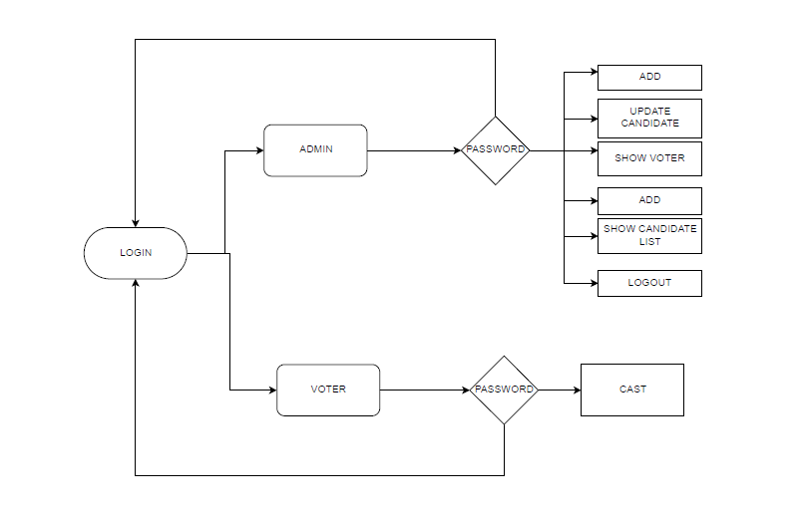

**FIG 3.1 DATA FLOW DIAGRAM**

**3.3USE CASE DIAGRAMS**

The use case module is a catalogue of system functionality described using UML use cases. Each use case represents a single, repeatable interactions that a user or actor experiences when using the system. A use case typically includes one or more “scenarios” which describes the interactions that go on between the actor and the system, and documents the results and exceptions that occur from the user’s perspective. Use case may include other use cases as part of a larger pattern of interaction and may also extended by other use cases to handle exceptional conditions.

A use case is a coherent piece of functionality that a system can provide by interacting with actors. For example, a customer actor can buy a beverage from a vending machine. The customer inserts money in to the machine, makes a selection, and ultimately receives a beverage. Similarly, a repair technician can perform scheduled maintenance on a vending machine. Proposed Model will make use of the following

**3.4 ER DIADRAM**

An **entity-relationship diagram** (**ERD**) is a data modelling technique that graphically illustrates an information system's entities and the relationships between those entities. An **ERD** is a conceptual and representational model of data used to represent the entity framework infrastructure.

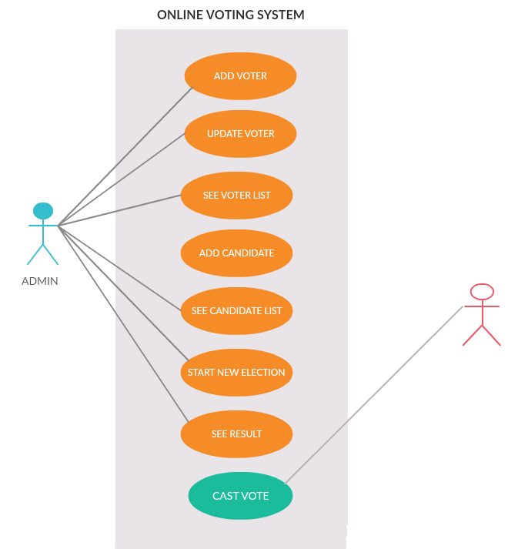

**FIG 3.2 USE CASE DIAGRAM**

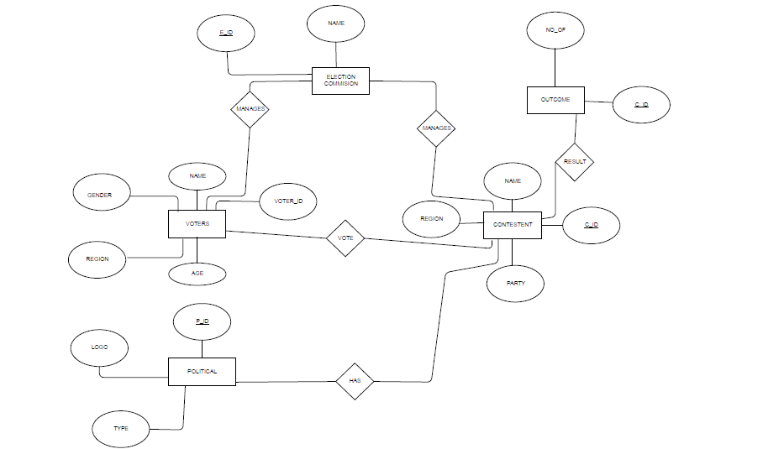

**FIG 3.3 ER DIADRAM**

**CHAPTER 4 FRONT END BACK END**

**4.1FRONT – END AND BACK-END**

In their most general meanings, the terms front end and back end refer to the initial and the end stages of a process flow. In software design, the **front-end** is the part of a software system that deals with the user, and the **back-end** is the part that processes the input from the front-end. The separation of software systems into "front ends" and "back ends" is a kind of abstraction that helps to keep different parts of the system separated. The general idea is that the frontends’ responsible for collecting input from the user, which can be in a variety of forms, and processing it in such a way that it conforms to a specification that the back-end can use. The connection of the front-end to the back-end is a kind of interface.

Front-end and back-end are terms used to characterize program interfaces and services relative to the initial user of these interfaces and services. (The "user" may be a human being or a program.) A”front-end” application is one that application users interact with directly. A "back-end" application or program serves indirectly in support of the front-end services, usually by being closer to the required resource or having the capability to communicate with the required resource. The back-end application may interact directly with the front-end or, perhaps more typically, is a program called from an intermediate program that mediates front-end and back-end activities. These terms acquire more special meanings in particular areas:-

(1) For software applications, front end is the same as user interface.

(2) In client/server applications, the client part of the program is often called the front end and the server part is called the back end.

(3) Compilers, the programs that translate source code into object code, are often composed of two parts: a front end and a back end. The front end is responsible for checking syntax and detecting errors, whereas the back end performs the actual translation into object code.

**CHAPTER 5**

**IMPLEMENTATION**

1. **DOWNLODING THE REQUIRED SOFTWARES**

Following software should be installed:

* JDK <https://download.oracle.com/otn-pub/java/jdk/8u191-b12/2787e4a523244c269598db4e85c51e0c/jdk-8u191-windows-i586.exe?AuthParam=1541769368_1f7ca398b510bc498593acf5675934cb>
* NETBEANS IDE: <https://download.netbeans.org/netbeans/8.2/final/bundles/netbeans-8.2-windows.exe>
* MYSQL: <https://cdn.mysql.com//Downloads/MySQL-5.7/mysql-5.7.24-winx64.zip>
* Mysql JDBC jar: <https://cdn.mysql.com//Downloads/Connector-J/mysql-connector-java-8.0.13.tar.gz>

1. **RUNNING MYSQL AND CREATING DATABASE ON MYSQL**

Run MySql command line client. Enter password then use create database command

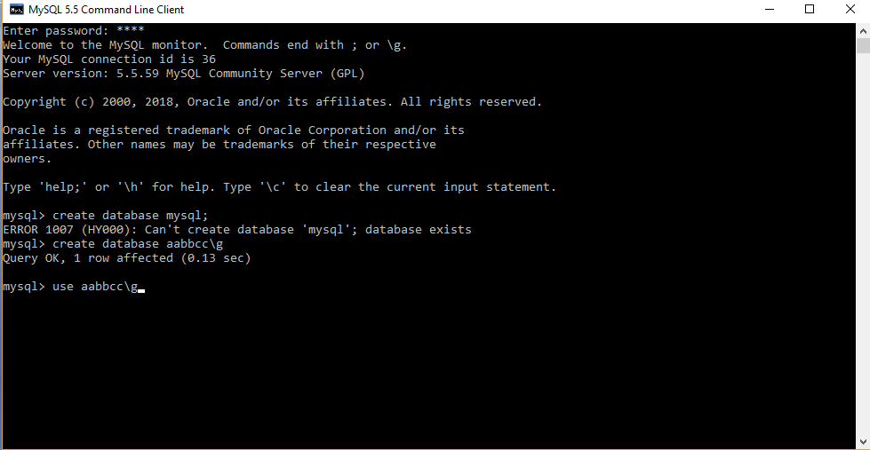

**FIG 5.1 MYSQL DATABASE CREATION**

1. **CREATE TABLE AND INSERT VALUES**
2. Change database using **use** command**.**
3. Use create table command to create table
4. Use insert into command to insert values

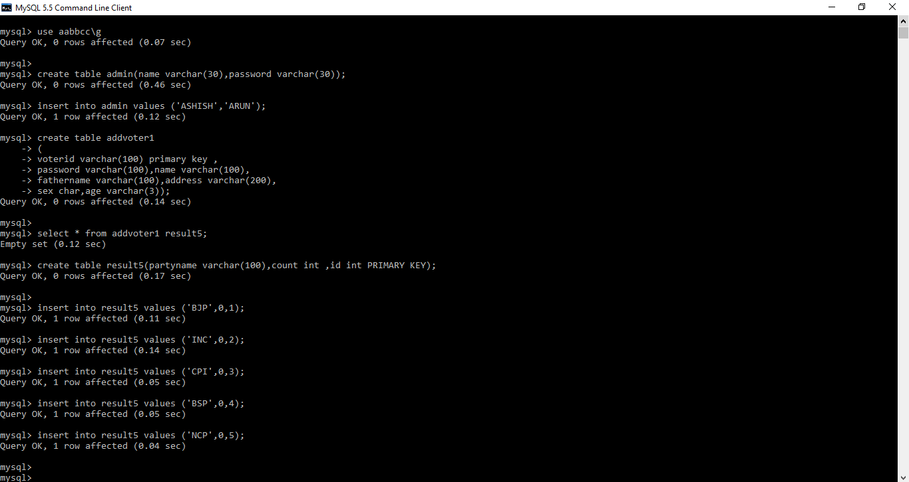

**FIG 5.2 CREATING TABLES AND INSRTING VALUES**

Use show table command to see which tables are created

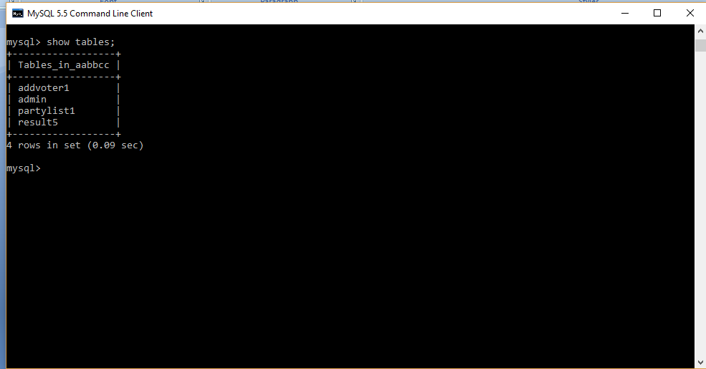

**FIG 5.3 TABLES LIST**

1. **FRONTEND CODE IN JAVA AND CONNECTION TO DATABASE**

Open NETBEANS. Go to files->new project. The following window will open choose java->java application->next

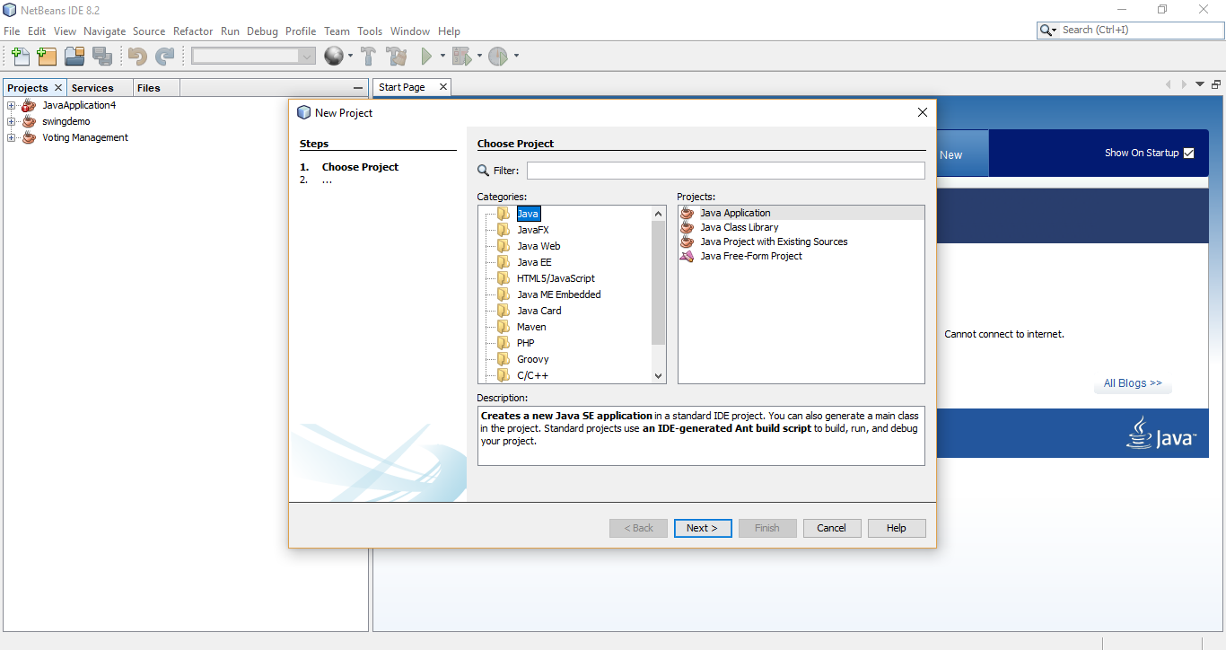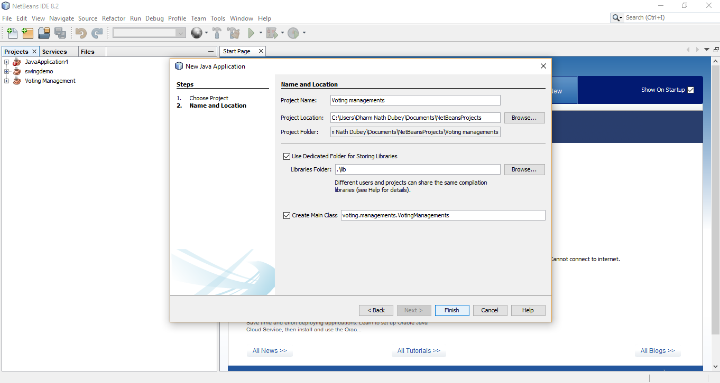

**FIG 5.4 NETBEANS IDE PROJECT CREATION**

Note that the voting, management are 2 folders. Management is a sub directory of voting. The contents of management are as follows.

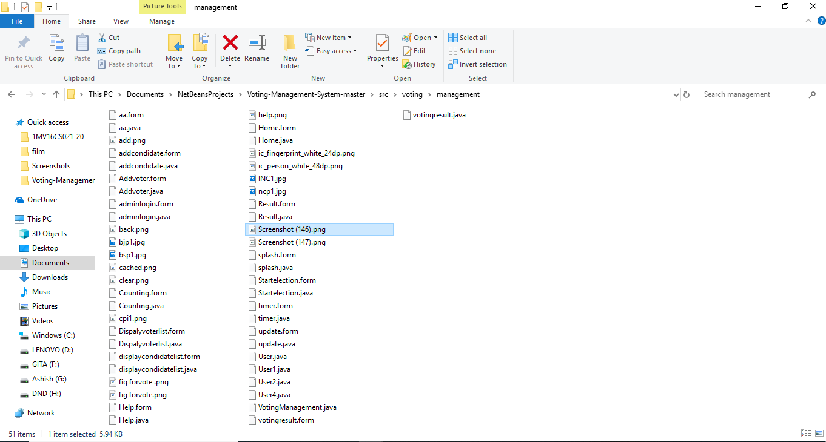

**FIG 5.5 JAVA FILES AND SUPPORTING IMAGES AND FORMS**

**To Connect With Mysql The Code In Java Is**

String DB_URL = "jdbc:mysql://localhost/dbms";

// STEP 1asfff: Database credentials

String USER = "root";

String PASS = "root";

Statement stmt = null;

//STEP 2: Register JDBC driver

Class.forName("com.mysql.jdbc.Driver");

//STEP 3: Open a connection

Connection con = DriverManager.getConnection(DB_URL,USER,PASS);

* Note: You should import required packages (java.sql.*). And should add JDBC jar.

1. **HOW THE FUNCTIONS ARE WORKING**

Run the project. It starts from VotingManagement.java

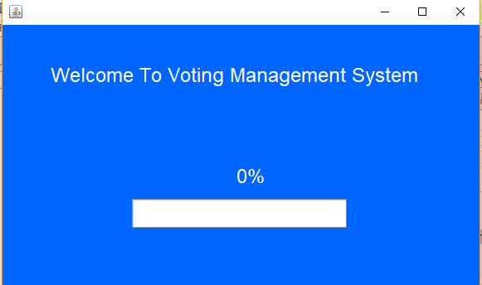

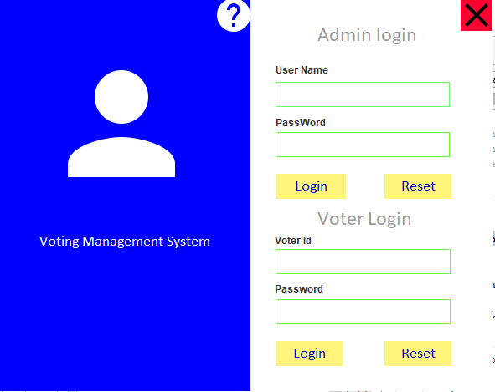

**FIG 5.6 LOGIN USER INTERFACE**

There are two login admin and voter.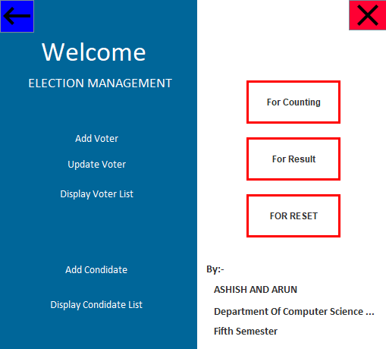

**FIG 5.7 ADMIN LOGIN**

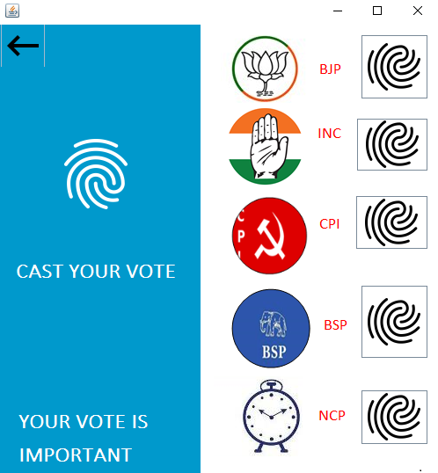

**FIG 5.8 VOTER LOGIN**

**CHAPTER 6: WORKING AND RESULT**

1. **ADDIND A NEW VOTER/CANDIDATE**

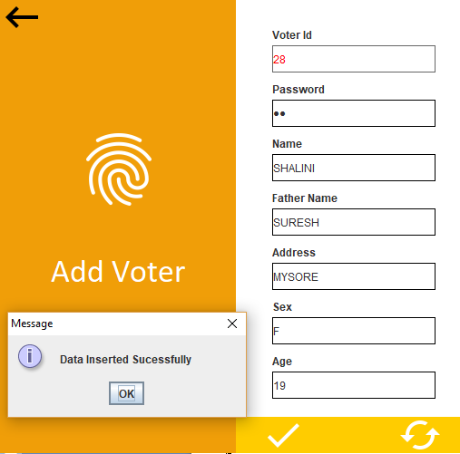

**FIG 6.1 ADDING VOTER**

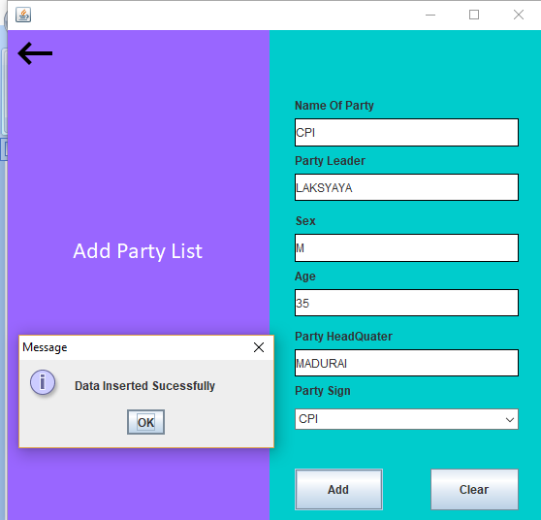

**FIG 6.2 ADDING CANDIDATE**

**2 VIEWING CANDIDATE/VOTER LIST**

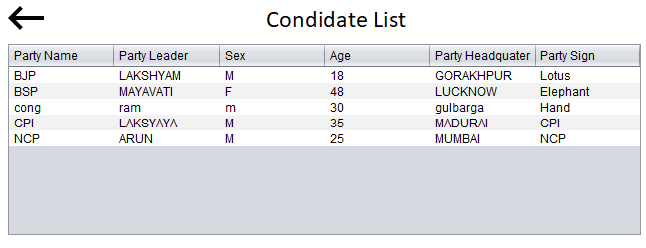

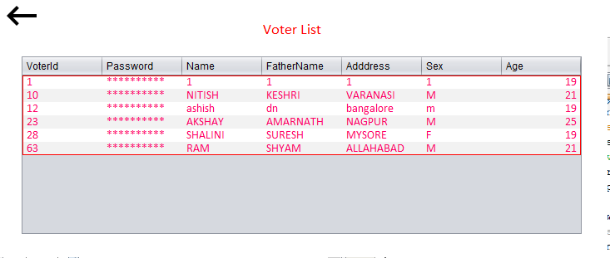

**FIG 6.3 CANDIDATE LIST AND VOTER LIST**

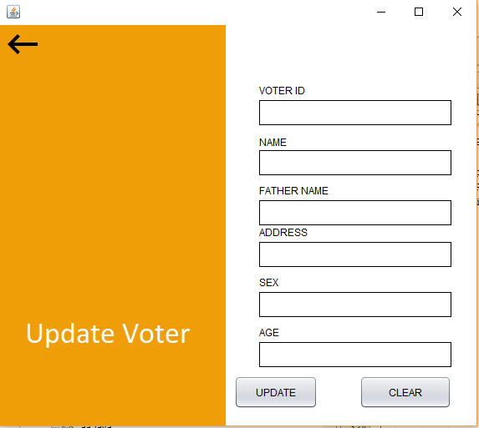

**FIG 6.4 UPDATE VOTER**

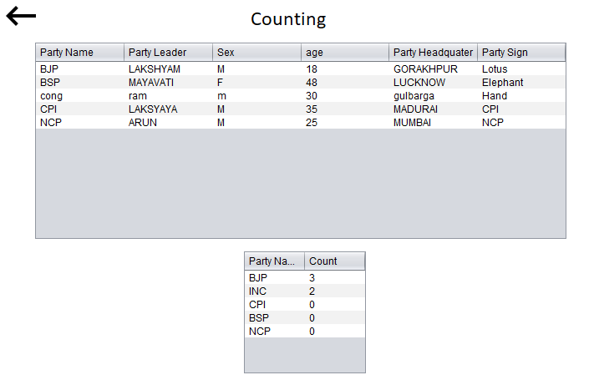

**FIG 6.5 COUNTING**

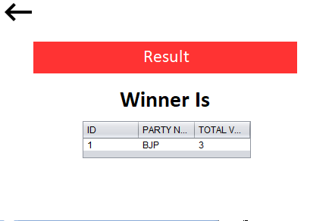

**FIG 6.6 RESULT**

**CHAPTER 6: CONCLUSION**

This Online Voting system will manage the Voter’s information by which voter can login and use his voting rights. The system will incorporate all features of voting system. It provides the tools for maintaining voter’s vote to every party and it count total no. of votes of every party. There is a DATABASE which is maintained by the ELECTION COMMISION OF INDIA in which all the names of voter with complete information is stored.

In this user who is above 18 year’s register his/her information on the database and when he/she want to vote he/she has to login by his id and password and can vote to any party only single time. Voting detail store in database and the result is displayed by calculation. By online voting system percentage of voting is increases. It decreases the cost and time of voting process. It is very easy to use and it is vary less time consuming. It is very easy to debug.

**BIBLIOGRAPHY**

* **LINKS**

1. <https://www.youtube.com/user/navinreddy20>
2. <https://www.youtube.com/user/javaboynavin>
3. <https://github.com/akdubey2701/DBMS-Projects-A-section-2018.git>
4. <https://www.guru99.com/java-swing-gui.html>

* **BOOKS**

1. The complete reference java :Herbert schildt <http://iiti.ac.in/people/~tanimad/JavaTheCompleteReference.pdf>